**Homepage**

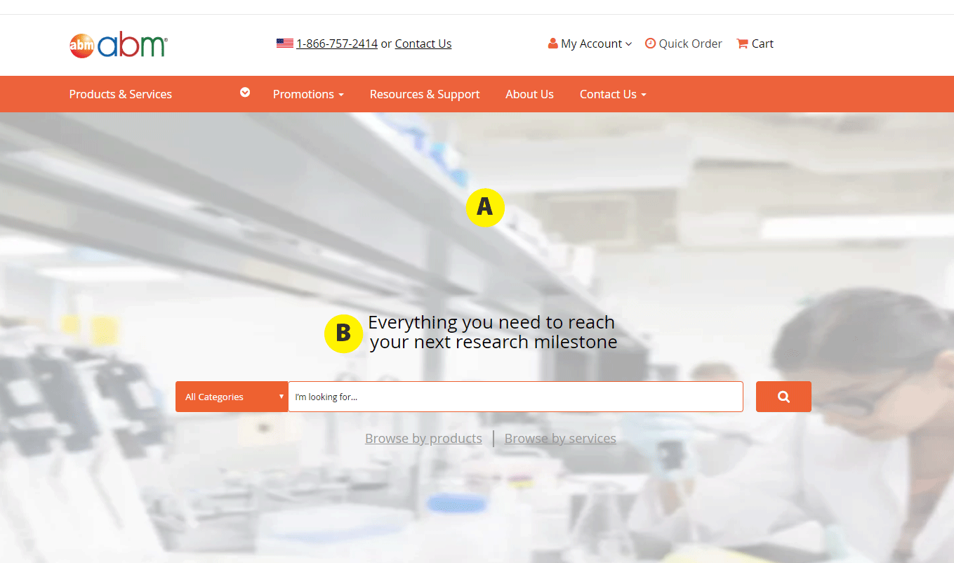

Notes:

* **A: Banner**
  + Height: 600px (image can be cut off/cropped)
* **B: Heading**
  + font-size: 3.5em (46px)
  + font-weight: 700
  + line-height: 135%

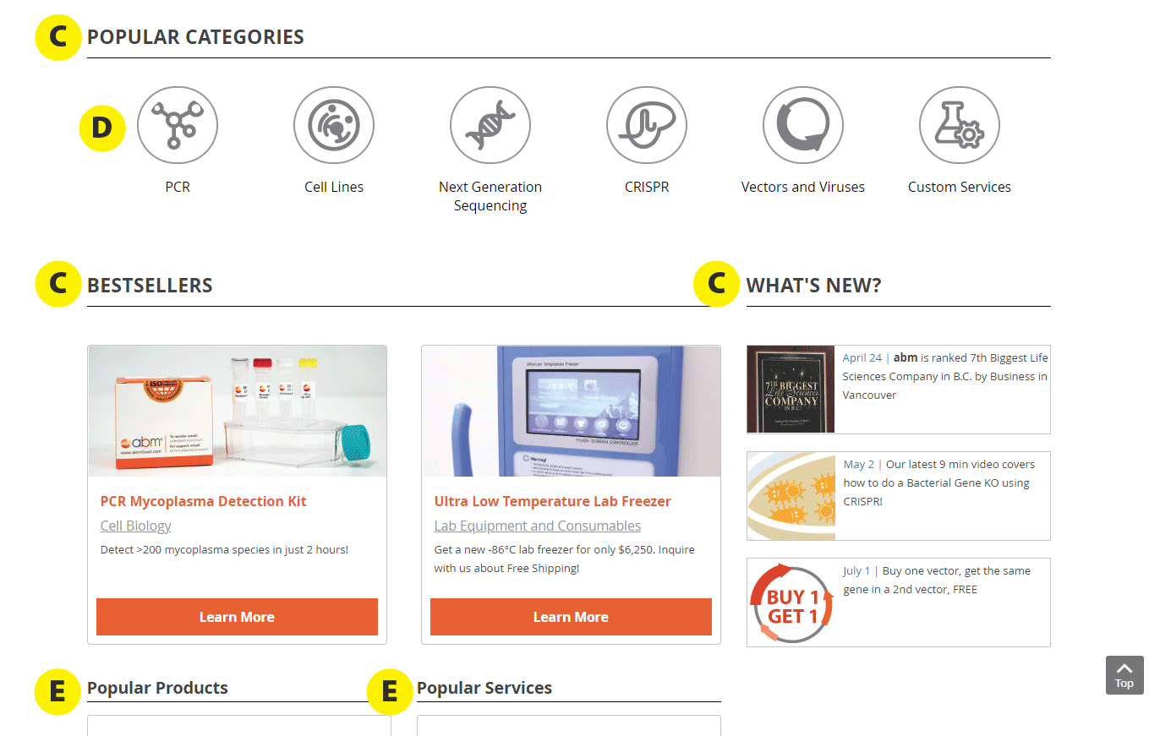

* **C: Headings**
  + Remove uppercase
  + color: #000
  + border: 1px solid #babcbe
  + font-size: 2.15em (28px)
  + Add 50px space between the banner at the top and “Popular Categories”
* **D: Icons**
  + Is there space to keep the icon image the same size, but increase the padding between the icon and the circle? Eg. Have more padding like the mockup here, or similar to the icons on the Resources & Support page:   
      
    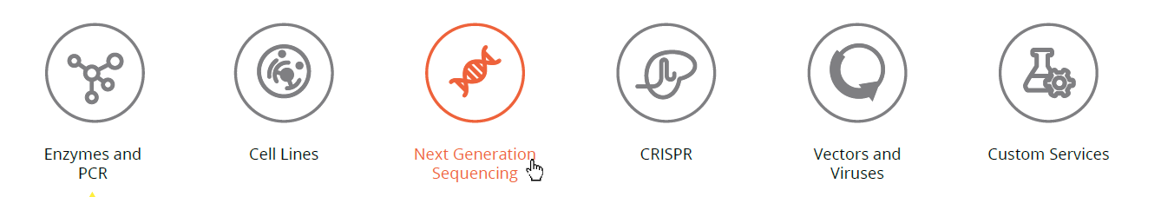
  + Make border color and size same as the ones on Resources & Support Page
    - border: 3px solid #808083
  + Since the icon images are .svg files, is it possible to have it change color to #ef6331 on hover like seen here: <https://css-tricks.com/almanac/properties/f/fill/#article-header-id-1>
* **E: Headings**
  + Remove bottom border under the text
  + color: #000

The middle section is actually not correct, it is supposed to have a grey background (#f1f2f2) like the testimonials section on the Resources & Support page:

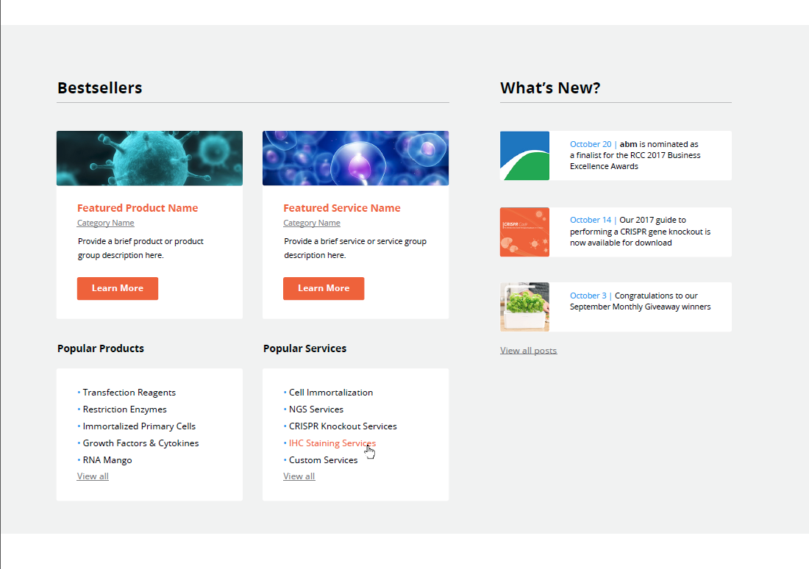

Is it possible to implement this background color?